**Problem 1:**

clear; clc; close all;

n=0:200;

M=100; % Size of window

w1 = 0.05*pi;

w2 = 0.20*pi;

w3 = 0.35*pi;

wa = 0.15*pi;

wb = 0.25*pi;

s = sin(w2*n); %signal

v1 = sin(w1*n); %Noise part 1

v2 = sin(w3*n); %Noise part 2

v = v1+v2; % Total Noise

x = s+v; % Polluted signal x(n)

w = 0.54 - 0.46.*cos((2*pi).*n/M); % Window Function

h = (w/pi).*(wb.*sinc((wb/pi).*(n-M/2)) - wa.*sinc((wa/pi).*(n-M/2))); % Filter

y = filter(h,1,x); %Filtered Signal

%% plot signal and noisy signal

figure; plot(n,x);

hold on;

plot(n,s);

title('x(n) and s(n)');

hold off;

%% plot filtered signal

figure ;

plot(n,s);

hold on;

plot(n,y);

title('s(n) and filtered x(n)');

hold off;

%% plot filtered noise and noise signal only

figure ;

plot(n,v);

hold on;

plot(n,filter(h,1,v));

title('v(n) and filtered v(n)');

hold off;

%% Plot frequency response of filter

firFilt = dsp.FIRFilter('Numerator',h);

[H,omega]=freqz(firFilt);

figure; plot(omega,abs(H));

title('Magnitude response of filter');

xlim([0,0.4*pi]);

xticks([0 0.05*pi 0.1*pi 0.15*pi 0.20*pi 0.25*pi 0.30*pi 0.35*pi 0.4*pi])

xticklabels({'0','\omega_1','0.1\pi','0.15\pi','\omega_2','0.25\pi','0.3\pi','\omega_3','0.4\pi'})

**Output:**

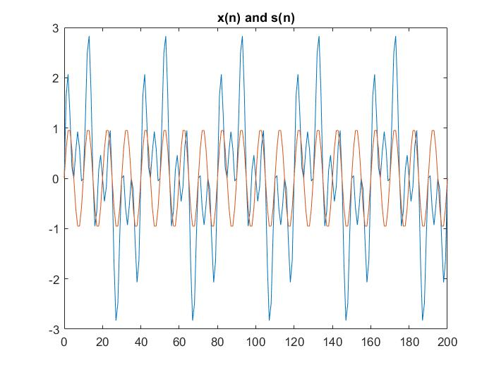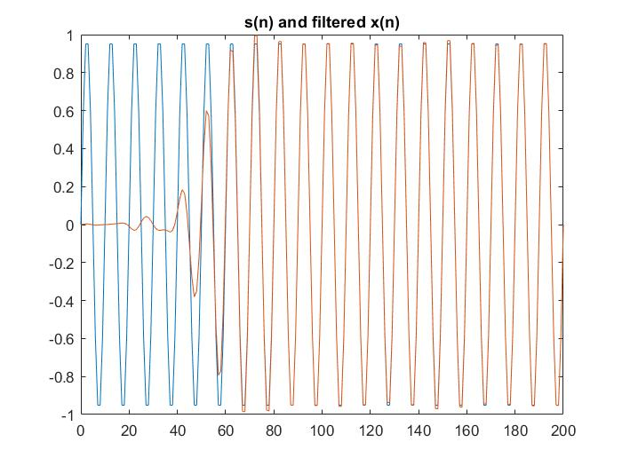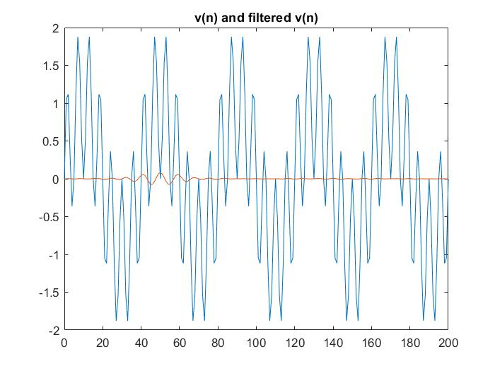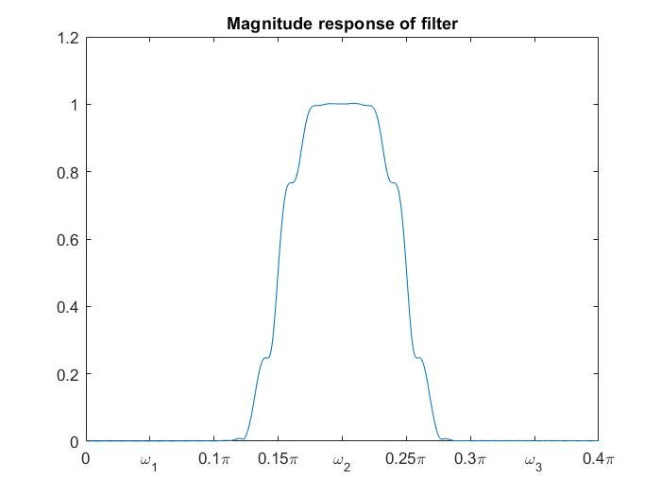

**Problem 2:**